COastal Landscape Transect Model (COLT)-Restoration Model User’s Guide
This code builds upon the following works:
- Kirwan et al. (2016). (https://doi.org/10.1002/2016GL068507).
- Valentine et al. (2023). [CoLT]( https://doi.org/10.1038/s41467-023-36803-7); code found here: https://csdms.colorado.edu/wiki/Model:Coastal_Landscape_Transect_Model_(CoLT)
1. Getting Started
1.1 Save program file to computer
If you are running the COLT on a new machine, you must save the all of the program files under one folder. Copy the “COLT-Restoration.zip” directly to your C drive, and unzip the contents of the file into a new folder, which will become the main directory of the model, where all model functions, plotting functions, inputs, and outputs are stored and name the folder “COLT”.
1.2 Main file contents
The following are the model functions which should be included in your COLT folder at the top level. These functions are required to run the model. Following the name of each function is a brief description of what each does:
Model Functions
biodepth Function to distribute belowground biomass with depth, as opposed to only the surface layer. Calculates exponential decay function to the depth of decomposition and then distributes the organic matter according to this function.

buildtransect Creates model domain and initial morphology of the bay, marsh,and upland slope. Marsh and bay depth are set to values close to equilibrium for the given sea level rise and suspended sediment concentrations.

calcFE Function to calculate the flux of organic matter (FE_org) and the flux of mineral sediment (FE_min) from the marsh to the bay,using the fetch for the current year (bfoc) the fetch for the previous year (bfop) and the stragtigraphy of organic and mineral deposition

decompose Decomposes all of the organic sediment within the marsh soil profile at a rate determined by depth.

evolvemarsh Calculates biomass and mineral and organic deposition, for each cell in the marsh as a function of flooding frequency. And calculates the total flux of sediment onto the marsh from the bay.

funBAY Determines change in bay depth and width by solving mass balance between fluxes of sediment into and out of the bay from marsh edge erosion, tidal exchange with the outside sediment source, and sediment deposited onto the marsh surface. From Mariotti and Carr (2014).

POOLstopp5 Necessary routine function to run ode solver for funBAY

transectwithtransectspinup Main function for the dynamic model for the morphological evolution of a backbarrier basin with marshes, mudflats, and an upland slope.
*This function is so named because it uses the stratigraphy generated from a transect-based spinup (in contrast to previous model version which have a separate spinup function that does not distribute organic matter to depth or allow for decomposition)

wavek Computes wave number via dispersion relationship

wavetau Calculates wave bed shear stress, as a function of fetch, wind speed, and bay depth. From Mariotti and Fagherazzi (2013)

waveTRNS Calculates wave power density at marsh boundary. From Mariotti and Carr (2014)

YeV Calculates wave height (Hs) and period (Tp) for a given fetch, wind speed, and depth; based on a set of semi-empirical equations Young and Verhagen (1996)

Plotting Functions
cfphase Creates phase diagrams of the results for a range of SSC and SLR for different upland slope values (recreate figure from Kirwan et al. 2016)

dMWvT Plots change in marsh width, as a function of edge erosion and forest retreat, through time for a given RSLR and Co

plotbaydepth Plots bay width and depth versus time

plotdeposition Function to plot the deposition of mineral and organic matter over the marsh surface for a given time step (ts) from a given model run (based on input parameters.

plotsurface Function to plot the surface profile for a given time step (ts) from a given model run (based on input parameters.

rgb Gives colormaps for plotting, written by Kristján Jónasson

Calibrate init conditions folder*:
*These files are used in the functions buildtransect and buildtransectspinup. You will not need to run these files or open this folder if you parameterize fetch at 5000 and wind speed at 6 m/s. Otherwise, you will need to rerun these files.

calcDBequil Function to find the initial condition for bay depth at which the model will experience the lowest rate of change. Outputs an array of bay depths for a given combination of rate of sea level rise and external sediment supply. Will produce a different array for each fetch and wind speed conditions.

calcDMequil Function to find the initial condition for marsh depth at which the model will experience the lowest rate of change. Outputs an array of marsh depths for a given combination of rate of sea level rise and external sediment supply. Will produce a different array for each fetch and wind speed conditions.

Equilibrium Bay Depth.mat This matrix file contains the equilibrium bay depths for a range of SSC and RSLR values, for a given bay fetch.

Equilibrium Marsh Depth.mat This matrix file contains the equilibrium marsh depths for a range of SSC and RSLR values, for a given bay fetch.

funMARSH A 3-point dynamic model for the moprhological evolution of a backbarrier basin with marshes and mudflats – written by Giulio Mariotti

wetland3p Morphodynamic model that solves for changes in bay depth, used to determine equilibrium bay depth for a given set of conditions.

Run Files

This folder contains the run files where model inputs and outputs will be stored. It includes an example run file folder. Each run file will include an “Outputs” folder with all of the outputs variables and plots from the model run, and an “Input variables” where all of the input variables to be used for running the model are entered.

SpinUp Folder*
*use these functions for a faster spinup and/or if you do not need autochthonous organic matter distributed to depth and decomposition processes included. Otherwise, use the transectspinupfiles for a spinup that does distribute OM to depth and resolve decomposition but requires more computation time*

buildstrat Function to take outputs from 1000yr model spinup and build a stratigraphy to use for all model runs

evolvemarsh Calculates biomass and mineral and organic deposition, for each cell in the marsh as a function of flooding frequency. And calculates the total flux of sediment onto the marsh from the bay.

Spinup Function to simulate the formation of a 500m wide marsh onto a gentle upland slope (m) under a given set of conditions for sea level rise (R) and suspended sediment concentration (C), to be used as the initial condition for model runs. Generates the initial conditions from which the model is run.

MarshStrat.mat Contains outputs from the spinup which set the initial conditions for model runs. Each unit has a “surface” (elev), a mass of mineral sediment “min”, and a mass of organic sediment, both allochthonous (organic_dep_alloch) and autochthonous (organic_dep_autoch), belowground biomass (bgb), fluxes between the marsh, bay, and external system (fluxes), and contains the history of mean sea level (msl) and sea-level rise (SLR). These datasets are named according to the conditions under which they were run (e.g., “spinupsMarshStrat_initialRSLR1_rampedfinalRSLR3_CO50”)

Transectspinups Files*
* these functions are new to this version of CoLT, based on the need to create a final spinup domain that is more in equilibrium with the marsh that continues to evolve within the transectwithtransectspinup function.

buildtransectspinup Creates model domain and initial morphology of the bay, marsh,and upland slope. Marsh and bay depth are set to values close to equilibrium for the given sea level rise and suspended sediment concentrations.
*difference between buildtransect and buildtransectspinup: buildtransectspinup builds bay, marsh, and forest topography using equilibrium depths from the “Calibrate init conditions” folder, whereas buildtransect in the main model run imports the bay and marsh elevation from the spinup and builds the forest stratigraphy

evolvemarshspinup Calculates biomass and mineral and organic deposition, for each cell in the marsh as a function of flooding frequency. And calculates the total flux of sediment onto the marsh from the bay.
**difference between evolvemarsh and evolvemarshspinup: evolvemarshspinup does not contain code for simulating breakwaters and reduction of suspended sediment due to breakwaters

transectspinup Main function for the dynamic model for the morphological evolution of a backbarrier basin with marshes, mudflats, and an upland slope.
**difference between transectspinup and transectwithtransectspinup: transectspinup builds the stratigraphy of bay and marsh that feed into transectwithtransectspinup. Transectspinup does not allow for marsh edge erosion/progradation, does not include breakwater and TLP functions, allows user-defined RSLR during the first 299 years and last 150 years (to approach equilibrium SLR rate at which transectwithtransectspinup function will start)

2. Running the spinup
2.1 Creating input variables spreadsheet for spinup
Before running the model, you must first create a set of input variables for the spinup to match the conditions for your model run. In your Windows Explorer, navigate to “C:\COLT”, and then open the “transectspinupfiles.” Copy and paste an existing folder (e.g., “SpinupExample”) and rename the new folder (e.g., “TestRun”). This will be your spinup folder, where all of your input variables and outputs from your spinup will be stored. Open up your spinup folder, and then open up the excel spreadsheet “Input variables”. Here you’ll see a list of input variables that look like this:
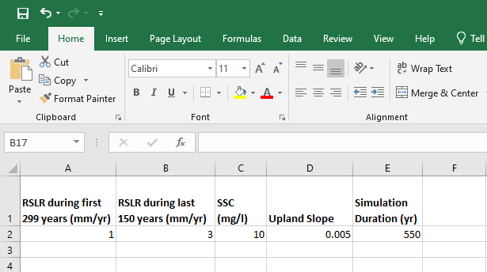
The RSLR during last 150 years (column B) is meant to allow the marsh to approach an equilibrium with the starting rate of RSLR that you choose for the model run. The first row gives the description of the input variables, and the second row is where you type in your input variables, in the units prescribed in the top row. Save and close the spreadsheet before running the model. Do not rename the spreadsheet.
2.2 Adding input variables for a range of conditions in the spinup
If you wish to run several spinups for a range of input conditions, you can add those to the rows below to create subsequent spinups (See picture below). Each row of input parameters represents one spinup for the given set of conditions. Each of these spinups will generate its own Outputs folder, saved under a name reflecting the inputs parameters chosen. (e.g., “Spinup_CO10_RSLRinitial1_rampedRSLRfinal3”). Each row will then be assigned a “spinup index” that you’ll input when you go to run the spinup, to indicate which row of input variables you would like the model to execute.
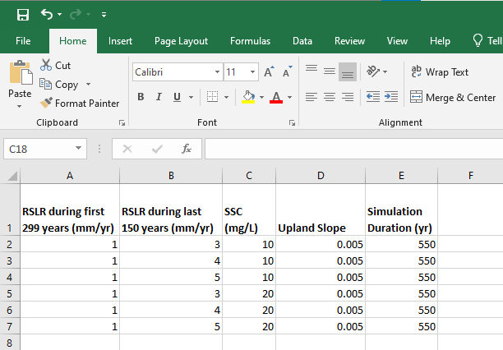
2.3 Running the spinup
2.3.1 Open MATLAB and Navigate to Directory
Before you can run the spinup, you must set the directory. From this directory, you can run the spinup, as well as any of the plotting functions.
Once you launch MATLAB, set your directory to the main directory folder for the model by selecting “Browse for Folder” and navigating to “COLT_Restorations”, or simply select “COLT_Restorations” from the dropdown box of recently used directories.
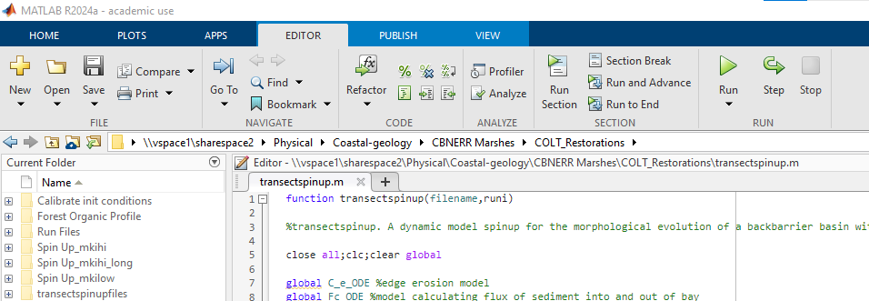
2.3.2. Starting the spinup in Matlab
To run the spinup, type the following into the MATLAB command line, replacing RunFileName with your actual run file name (e.g., transectspinup(‘RunFileName’)). To run multiple spinups in succession, start a for-loop that cycles through several lines of the “Input Variables” spinup conditions spreadsheet.
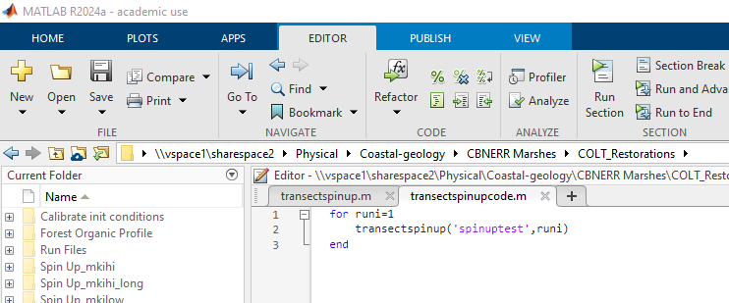
2. Running the model
2.1 Creating input variables spreadsheet for model
Before running the model, you must first create a set of input variables for the model to run. In your Windows Explorer, navigate to “COLT_Restorations”, and then open the “Run Files” folder. Copy and paste an existing folder (e.g., “Example”) and rename the new folder (e.g., “TestRun”). This will be your run folder, where all of your input variables and outputs from your model run will be stored. Open up your run folder, and then open up the excel spreadsheet “Input variables”. Here you’ll see a list of input variables that look like this:
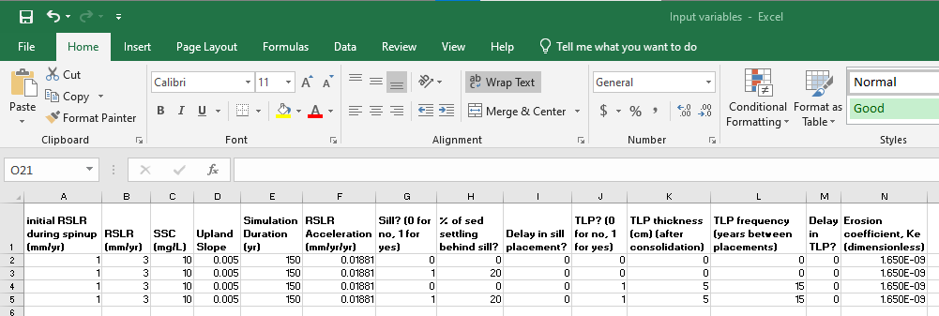
The first row gives the description of the input variables, and the second row is where you type in your input variables, in the units prescribed in the top row. The first four inputs (columns A–D) need to match the inputs for whichever spinup you are using. Realistic RSLR Acceleration rates (column F) and erosion coefficient rates (column N) are detailed in the transectwithtransectspinup.m input variables list (lines 48 and 56). Save and close the spreadsheet before running the model. Do not rename the spreadsheet.
If you wish to run your model for a range of input conditions, you can add those to the rows below to create subsequent runs (See picture above). Each row of input parameters represents one run for the given set of conditions. Each of these runs will generate its own Outputs folder, saved under a name reflecting the inputs parameters chosen. (e.g., “Outputs_CO10_RSLRA0.1106_spinuprampedRSLR1_runstartRSLR3_Breakwater0_SSCReduction0_breakwaterdelay551_TLP0_TLPthick0_TLPfreq0_TLPdelay551_Erosion1.65e-9”). Each row will then be assigned a “run index” that you’ll input when you go to run the model, to indicate which row of input variables you would like the model to execute.
2.2 Open MATLAB and Navigate to Directory
Use the same directory as you did for the spinup (setting COLT_Restorations as the file path). Make sure that you choose
2.3 Running the model
To ensure that the appropriate spinup files are inported into the model AND to make sure that your output file name is logical for your purposes, edit as needed Lines 81 and 98 in transectwithtransectspinup.m (see image below).
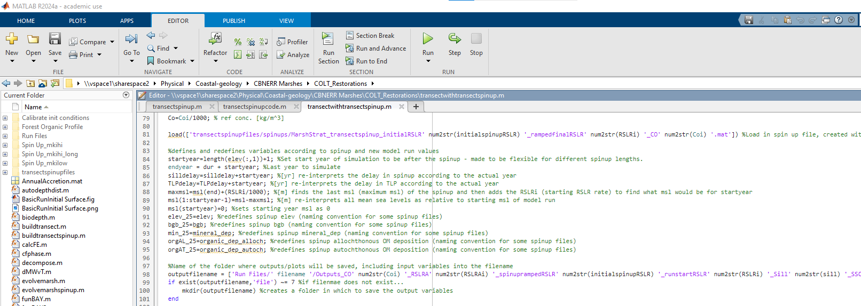
To run the model, type the following into the MATLAB command line, replacing RunFileName with your actual run file name (e.g., transectwithtransectspinup(‘Example’)). To run multiple spinups in succession, start a for-loop that cycles through several lines of the “Input Variables” spinup conditions spreadsheet.
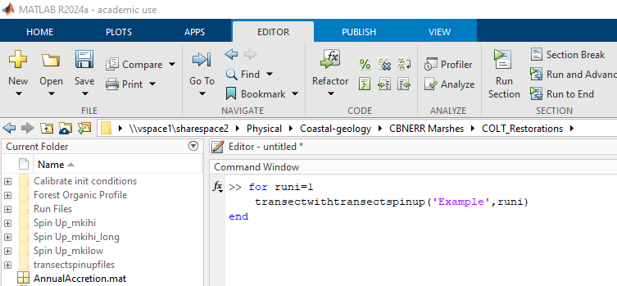
The model will run for the prescribed number of years using the input variables inputted on the first row of your Input variables spreadsheet, and will automatically save the output variables to the “Outputs” folder in your specified run file, reflecting the inputs parameters chosen. (ie- “Outputs_RSLR3_CO20_Slope005”).
4. List of Variables
4.1 Variables used in the text of the manuscript:
Model parameters. The data sources for all parameters developed for this model are listed in the column named as Source.
Table S2. Model parameters
Parameter | Description |  | Value | Source
Site condition parameters
P | Tidal period |  | 12.5 hr | [semidiurnal tides]
Amp | Tidal amplitude |  | 0.5 m | [microtidal marshes]
Wind | Wind speed |  | 6 m s⁻¹ | Fagherazzi and Wiberg (2009)
Mudflat parameters
W_{sf} | Settling rate on the mudflat |  | 0.5 x 10⁻³ m s⁻¹ | Morris et al. (2002)
Dist | Distance of shoaling profile from marsh edge |  | 10 m | Mariotti and Carr (2014)
𝜏_{cr} | Critical shear stress |  | 0.1 kg m⁻¹ s⁻² | Mariotti and Carr (2014)
λ | Bay bottom erosional coefficient |  | 0.0001 (dimensionless) | Smith & McLean (1977); Mariotti and Carr (2014)
γ | Water specific weight |  | 9800 kg m⁻² s⁻² | Mariotti and Carr (2014)
Salt marsh parameters
W_{s} | Settling rate on the marsh |  | 0.05 x 10⁻³ m s⁻¹ | Morris et al. (2002)
Λ | Decay coefficient for sediment deposition across the marsh surface |  | -0.0031 m⁻¹ | Kirwan et al. (2016)
ρ_{m} | Bulk density of mineral matter |  | 2000 kg m⁻³ | Morris et al. (2016)
ρ_{o} | Bulk density of organic matter |  | 85 kg m⁻³ | Morris et al. (2016)
k_{a} | Progradation coefficient |  | 2 (dimensionless) | Mariotti and Carr (2014)
k_{e} | Erosion coefficient |  | Varies between 1.65 x 10⁻⁹ and 9.95 x 10⁻⁹ s² m⁻¹ | Mariotti and Carr (2014)
B_{max} | Maximum biomass |  | 2500 g m⁻² | Morris et al. (2002)
d_{max} | Maximum depth below mean high water at which Spartina alterniflora can grow |  | 0.645 m (for TR =1) | McKee and Patrick (1988)
d_{min} | Minimum depth below mean high water at which Spartina alterniflora can grow |  | 0 m | McKee and Patrick (1988)
m_{k} | Coefficient of decomposition |  | 0.1 (dimensionless) | Reitl et al. (2021)
m_{u} | Depth at which decomposition stops |  | 0.4 m | Reitl et al. (2021)
ω | Depth at which belowground biomass is approximately one-third of the surface value |  | 0.27 m | Morris and Bowden (1986); Rybczyk et al. (1988); Megonigal et al. (2020); Reitl et al. (2021)
Forest parameters
B_{max,forest} |  | Forest biomass maximum | 5000 g m⁻² | Empirical, Fig. S1 (Chen and Kirwan, accepted in principle)
C_{0,abg} |  | Tree biomass value at marsh-forest boundary | 1000 g m⁻² | Empirical, Fig. S1 (Chen and Kirwan, accepted in principle)
b |  | Tree growth rate | 2 m⁻¹ | Empirical, Fig. S1 (Chen and Kirwan, accepted in principle)
C_{0,soil} |  | Background carbon accumulation in forest soils | 0.0001 g m⁻² | Empirical, Smith and Kirwan 2021
C_{wet} |  | Carbon layer from wetted soils | 5 g m⁻² | Empirical, Smith and Kirwan 2021
b_{soil} |  | Decay constant | 2 m⁻¹ | Empirical, Smith and Kirwan 2021
m |  | Upland slope | 0.001 (dimensionless) | Hussein 2009

4.1 Variables used in code:
amp Tidal amplitude (m) (is 2X tr)
B transect width (m)
Ba marsh progradation coefficient (--)
Be marsh erosion coefficient (m/yr/(W/m))
bfo initial bay fetch (m)
BMax maximum biomass (g/m2)
C_e_ODE SSC at marsh edge (kg/m3) for each model iteration
Co Reference concentration (kg/m3)
Cr reference suspended sediment concentration in the bay (kg/m3)
Df average bay depth over tidal cycle (m)
Dist reference distance from marsh edge (m)
Dm marsh edge depth (m)
Dmax maximum depth below high water that marsh vegetation can grow (m)
Dmin minimum depth below high water that marsh vegetation can grow (m)
Dmo marsh edge depth (m)
Dur number of years to simulate (yr)
E Net flux of sediment eroded from the marsh edge (m2/s)
Fac proportion of tide that the bay is flooded (--)
Fc Net flux of sediment lost through tidal exchange with external sediment supply (m2/s)
Fc_ODE Mass flux of Fc for each iteration (kg/s)
Fetch fetch (m)
Fm_min Mass flux of mineral sediment to the marsh from the bay
Fm_org Mass flux of organic sediment to the marsh from the bay
Fp_sum amount of sediment taken from ponds to recharge sedimentation to drowning interior marsh
Lamda mudflat erodibility coefficient (--)
Mki decomp coefficient
Msl Mean sea level (m)
Mui depth in marsh where decomp goes to 0 (m)
Mwo initial marsh width (m)
OCb organic content of uppermost layer of bay sediment (determines OC of SSC), %
P Tidal period (s)
Rhob bulk density of the bay bottom (initially all mineral) (kg/m3)
Rhom bulk density of the marsh edge (kg/m3)
rhoo organic matter bulk density (kg/m3)
rhos sediment bulk density (kg/m3)
RSLR relative sea level rise rat (m/s)
Slope upland slope
SLR Sea level rise for a given year (m/yr)
Tau excess shear stress (Pa)
Tcr critical shear stress (Pa)
Tr Tidal range (m)
Tw wave bed shear stress (Pa)
W wave power density at the marsh boundary (W)
Wind reference wind speed (m/s)
Ws Settling velocity (m/s)
Wsf Settling velocity on mudflat (m/s)

Values for Constants
rhos 2000
rob 2000
rhoo 85
P 12.5*3600*1
Ws 0.05 x 10-3
Wsf 0.5 x 10-3
Tcr 0.1
Wind 6
Amp 1.4/2
Ba 2
Lamda 0.0001
Dist 10
Bfo 5000

